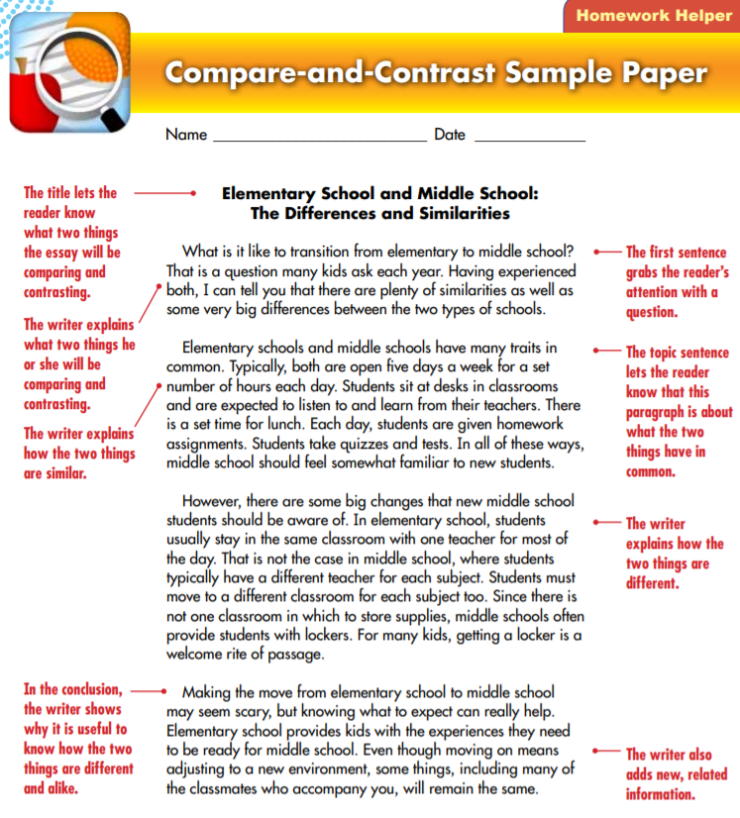

Picture obtained from https://www.eriesd.org/site/handlers/filedownload.ashx?moduleinstanceid=14835&dataid=13720&FileName=2.%20%20CompareContrastSampler.pdf
Use the graphic organizer to help you organize your thoughts and important points you find in the reading. After you are done filling it up you can then create a compare and contrast essay. Write your four to five-paragraph compare and contrast essay on the next page, below the graphic organizer.
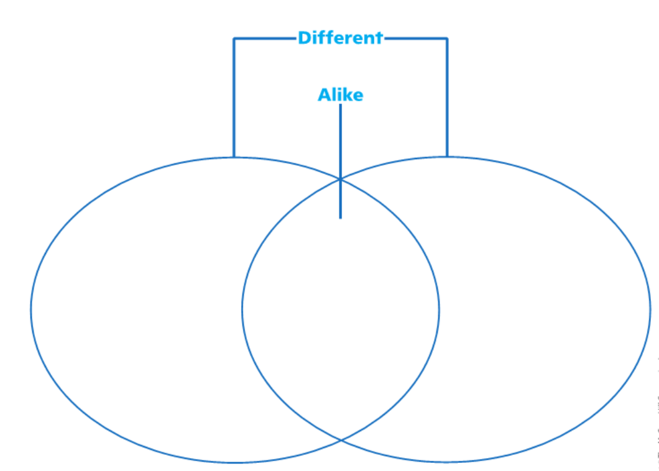
What do they have in common?
What are you comparing?
What are you comparing it to?

Write your essay here:

