Sample Explanatory Essay

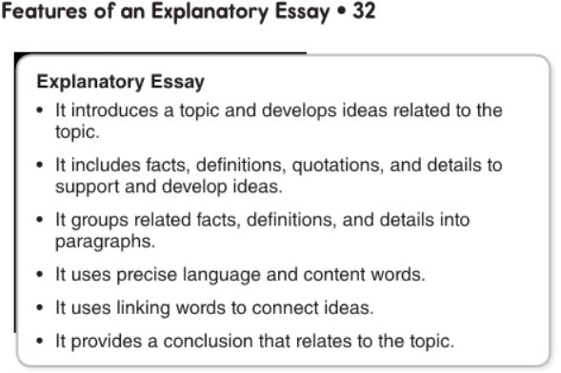

Use the graphic organizer on the next page to help you organize your thoughts and important points you find in the reading. After you are done filling it up you can then create an explanatory essay. Write your five-paragraph explanatory essay on the following page, below this graphic organizer.
Hook-

Background/Definition-

Thesis-

Topic 1- | Topic 2- | Topic 3-
Support/Evidence 1 | Support/Evidence 1 | Support/Evidence 1
Support/Evidence 2 | Support/Evidence 2 | Support/Evidence 2
Support/Evidence 3 | Support/Evidence 3 | Support/Evidence 3
Summary 1- | Summary 2- | Summary 3-
Thesis again-

Restate three big ideas from the body –

End with a Punch-
Write your essay here!

