Sample Opinion Essay

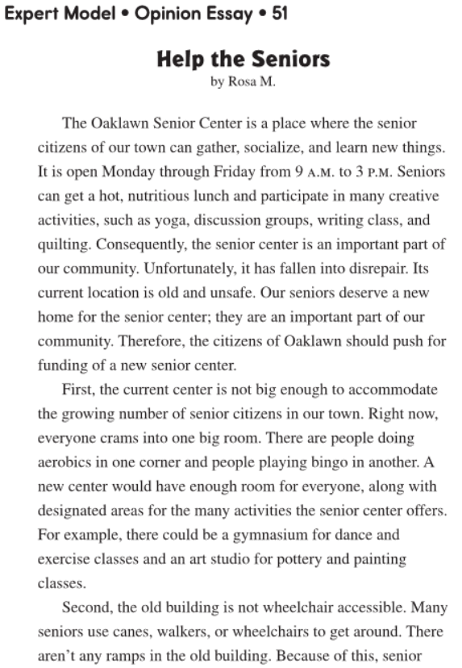

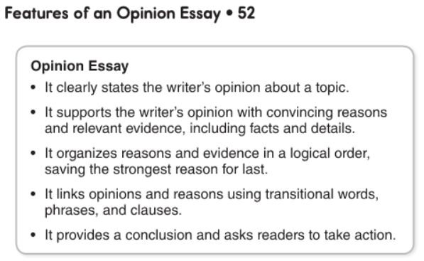
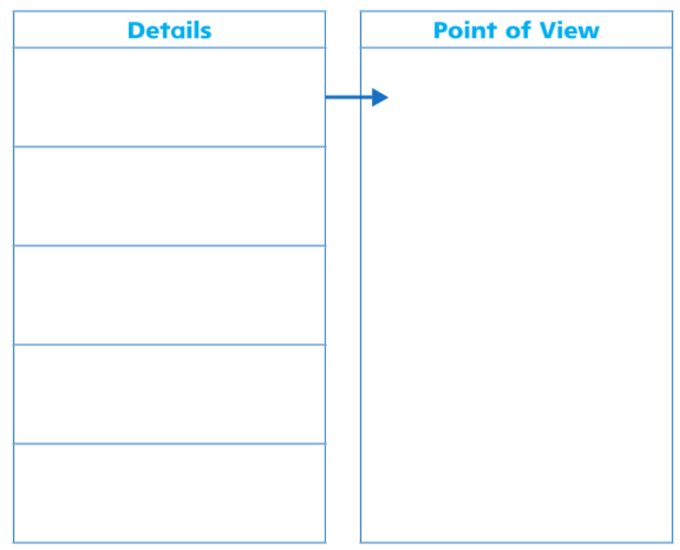
Use the graphic organizer to help you organize your thoughts and important points you find in the reading. After you are done filling it up you can then create an opinion essay. Write your five-paragraph opinion essay on the following page, below this graphic organizer.
Write your point of view here.
Write one detail that support your point of view here.
Write one detail that support your point of view here.
Write one detail that support your point of view here.
Write one detail that support your point of view here.
Write one detail that support your point of view here.

Write your essay here!

