Sample of a Summary

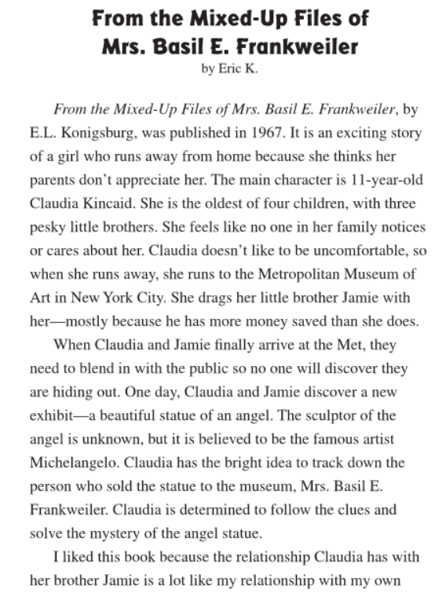

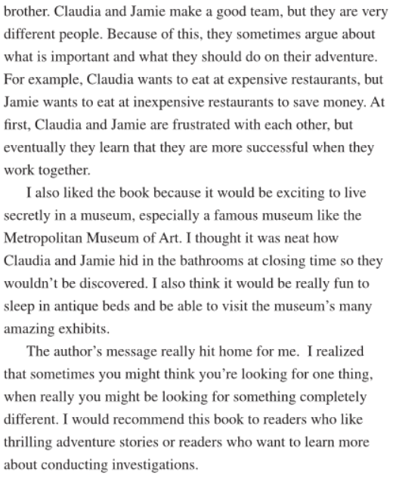

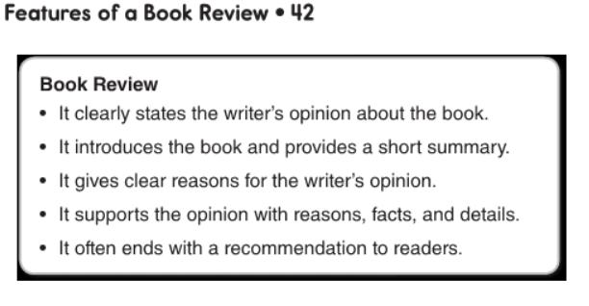

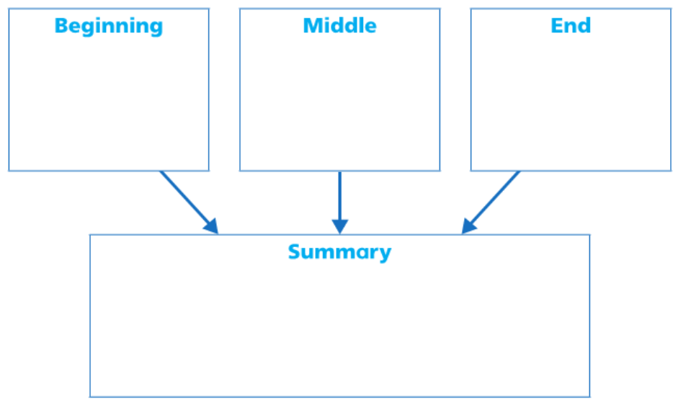
Choose one graphic organizer and use it to help you organize your thoughts and important points you find in the reading. After you are done filling it up you can then create a review. Write your review on the following page, below this graphic organizer.
Write what happened last.
Write what happened next
Write what happened first
Write everything in a paragraph using transitions and your point of view of the book. Answer the following questions Did you like it? What did you like about it? Would you recommend it? What would you have liked to see happen at the end?

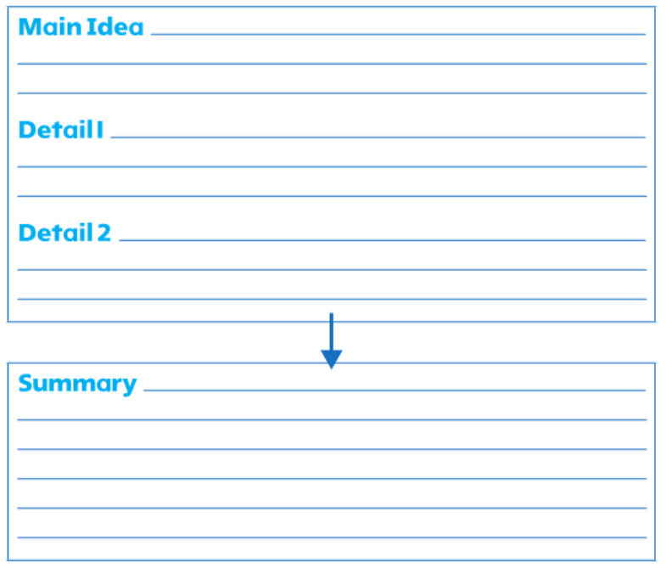
Write everything in a paragraph using transitions and your point of view of the book. Answer the following questions Did you like it? What did you like about it? Would you recommend it? What would you have liked to see happen at the end?

What is one key detail that supports the main idea?
What is another key detail that supports the main idea?
What is the main idea of the reading?

