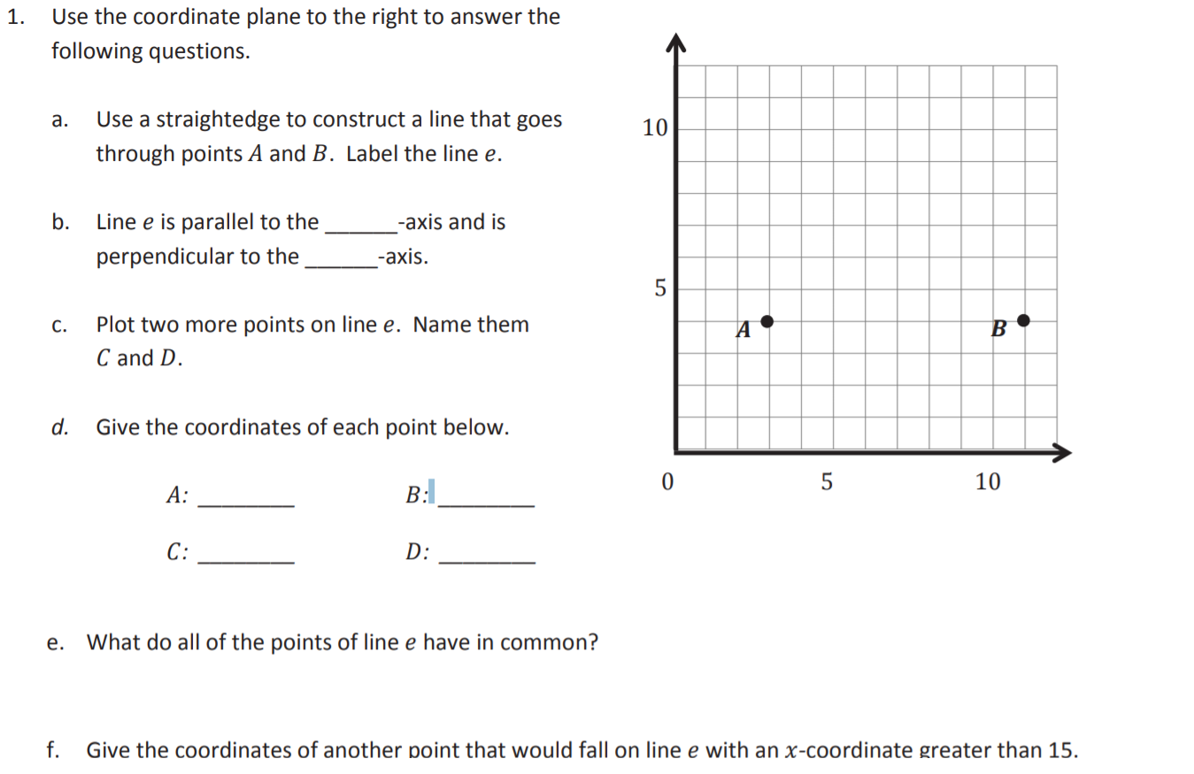
- Grab the line and place it where you think it should be.

- Write your answer in the boxes
E
- Grab each point and put them where you think they should be.
- Write your answer in the boxes as #,#
- Write your answer in the box
- Write your answer in the box as #,#

