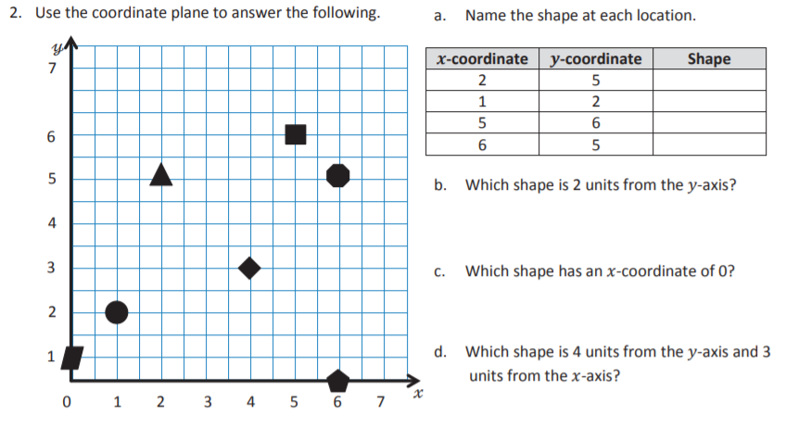

**Write here**

**Write here**

**Write here**

**Write here**