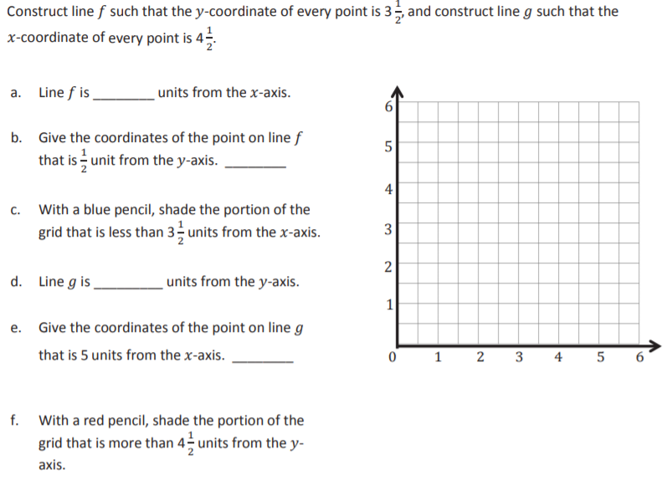
To fill the grid, grab and drag the lines, letters and squares at the bottom of the page to where you think they are supposed to be on the grid. Type your answers in the boxes.

f
g

