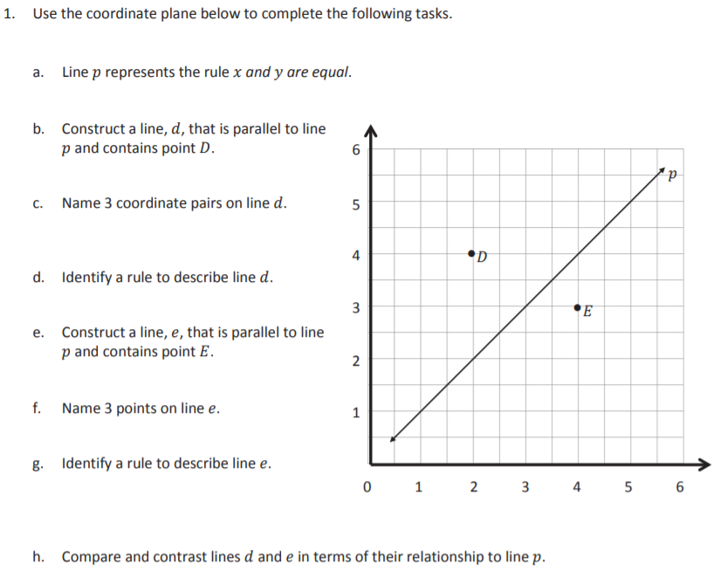
To fill the grid, grab and drag the lines and dots to where you think they are supposed to be on the grid. Notice that you can grab one end of the line and elongate it or make it go up or down. Type your answers in the boxes.

